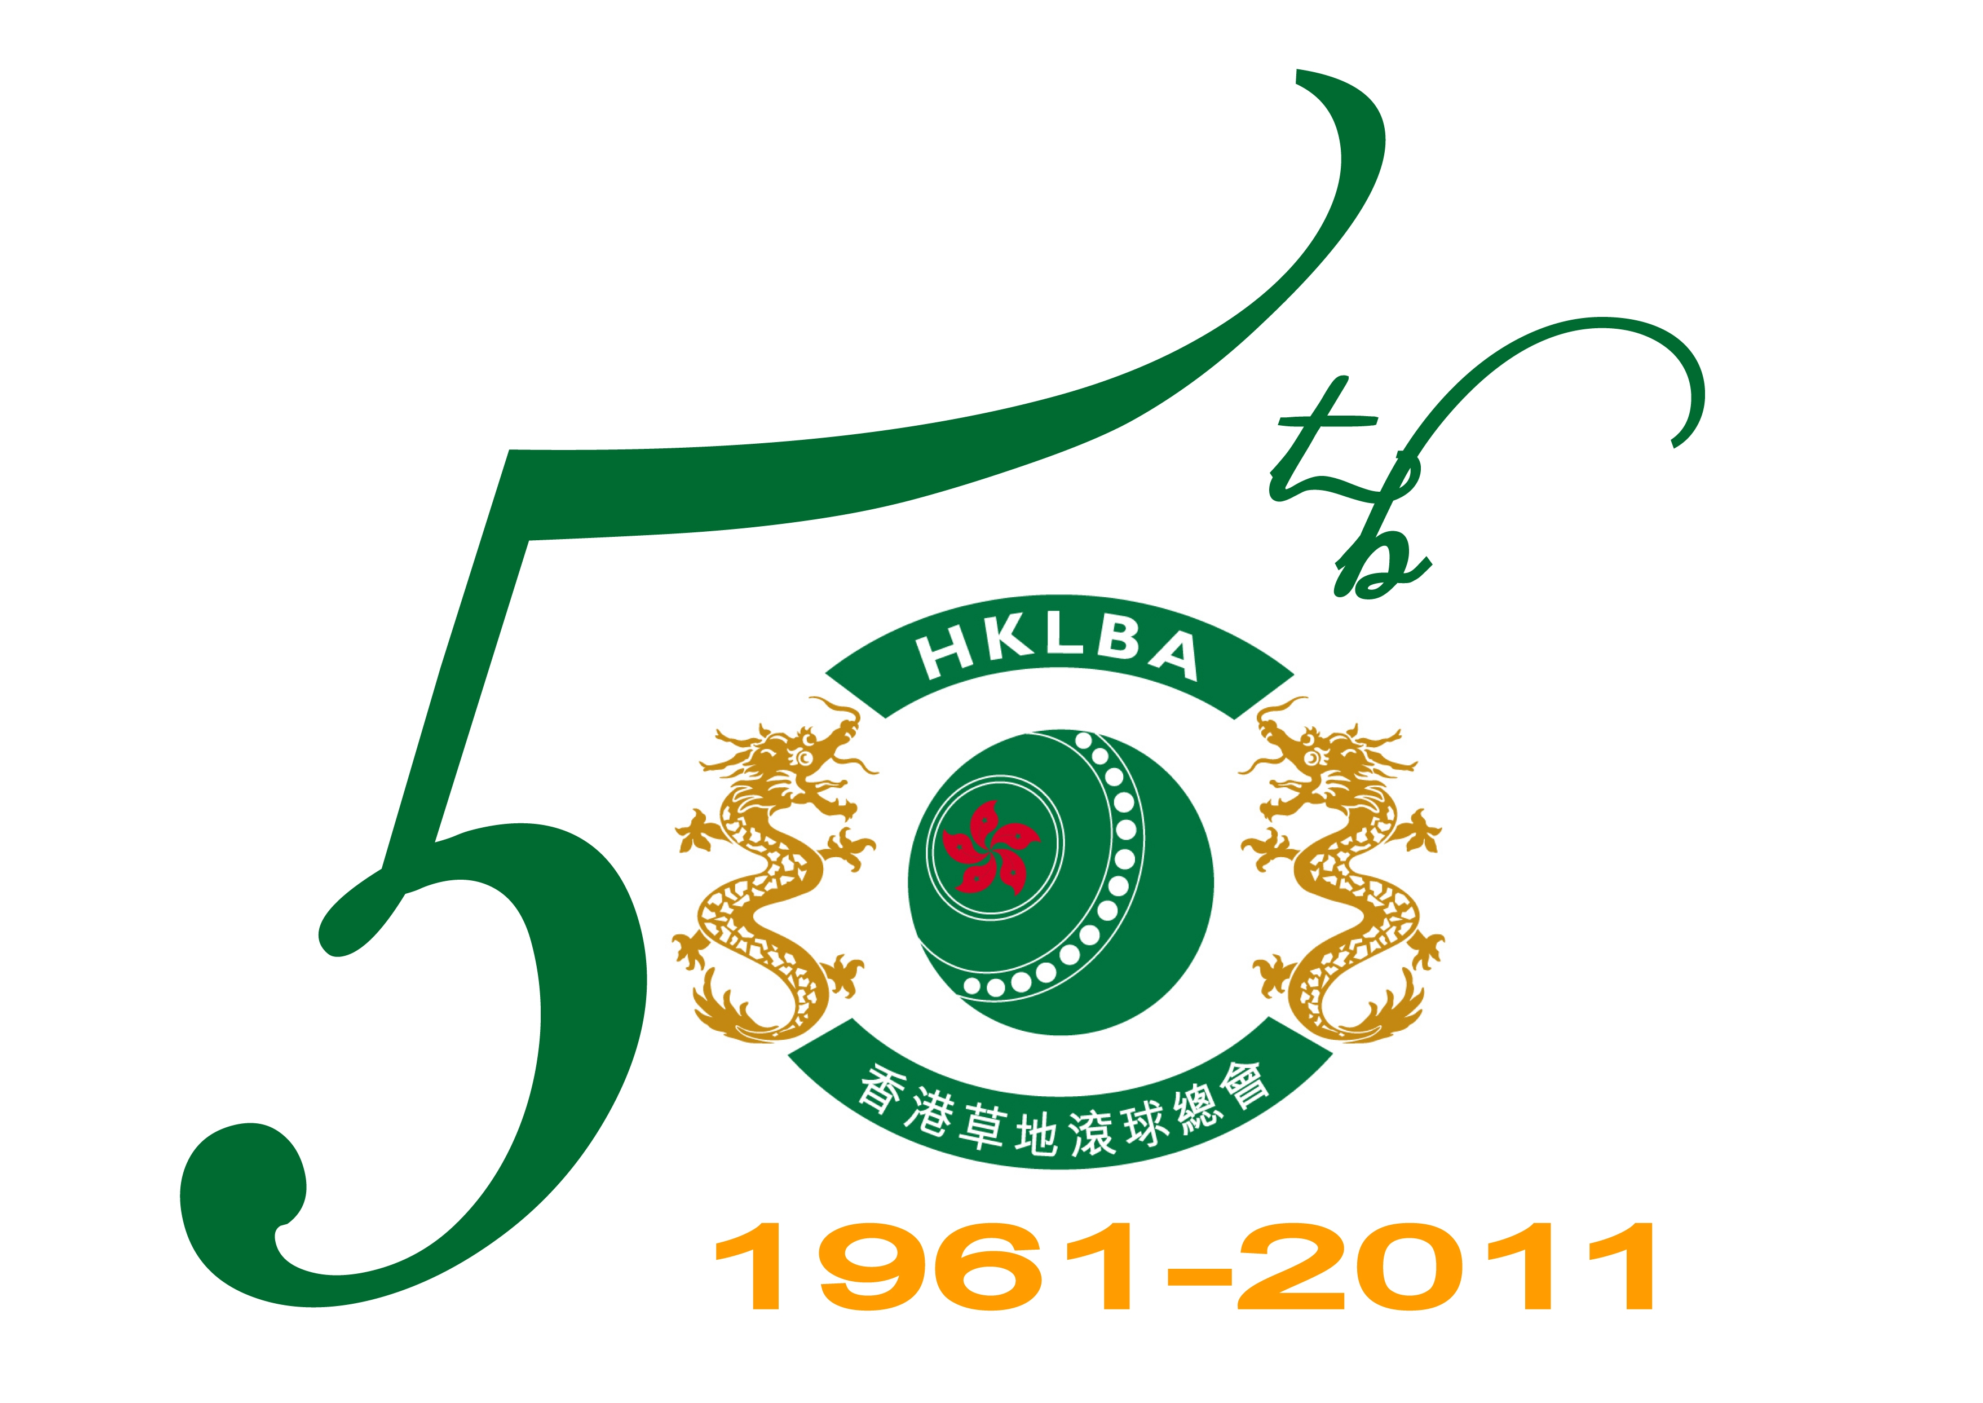 | HKLBA  Golden Jubilee Annual Presentation Dinner  Sunday 27 May 2012

The HKLBA G olden Jubilee Annual Presentation Dinner will be held at 6:30pm on Sunday, 27 May 2012 at the Sports Hall, Hong Kong Football Club. The subsidized cost is $250 for non-prize winners and $150 for prize winners (please refer to the prize winners list in the attached files).

In case entries exceed the maximum capacity, priority will be given to prize winners.

This form must be returned to the HKLBA office either by Fax (2577 5621) or E-mail : hklba@hklba.org on or before 30 April 2012.

Name |  | Mark “W” for Winners | Name |  | Mark “W” for Winners
1 |  |  | 13
2 |  |  | 14
3 |  |  | 15
4 |  |  | 16
5 |  |  | 17
6 |  |  | 18
7 |  |  | 19
8 |  |  | 20
9 |  |  | 21
10 |  |  | 22
11 |  |  | 23
12 |  |  | 24

Remarks : No show will be charged for the actual cost of $315.

Non-Prize Winners : $250 x persons = $

Prize Winners : $150 x persons = $

Total no. of entries : Total cost of entries : $

Contact person : (Tel : /Email : )

Club : Date :

