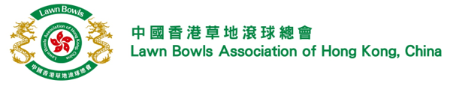

**Membership Application Form (updated 2024)**

Any competitively active club taking part in the sport of lawn bowls in Hong Kong may become a member of the Association if it complies with the requirements set forth by the Council of Management and under any Hong Kong SAR Government ruling bodies.

**Part I: Club Profile**

|  |  |  |  |  |  |
| --- | --- | --- | --- | --- | --- |
| Club Name (English)* |  | | | | |
| (Chinese) |  | | | | |
|  | | | | | |
| Correspondence Address |  | | | | |
|  |  | | | | |
|  | | | | | |
| Tel Number (General Line) |  | Website | |  | |
|  | | | | | |
| Email (General Enquiry) |  | | | | |
|  | | | | | |
| Business Registration Number * |  | | | | |
| Expiry date |  | | | | |
|  | | | | | |
| Certificate of Registration of a Society Number* | REF. CP/LIC/SO/ | | | | |
|  | | | | | |
| Number of Men Members* |  | | Number of Women Members* | |  |
|  | | | | | |
| Home Green* |  | | | | |

Details of Club Representative

|  |  |  |  |
| --- | --- | --- | --- |
| Title* | Mr Mrs Ms | | |
| Name (English)* |  | (Chinese) |  |
| Email* |  | Tel Number* |  |

**Part II: Submission of updated legal documents**

|  |
| --- |
| Please provide the following documents to support your application:   * Valid Business Registration Certificate / Valid Certificate of Registration of a Society * Memorandum and Articles of Association |

**Part III: Acknowledgement and Declaration**

|  |
| --- |
| “I, (name) , being the Chairman/Representative of the Club confirm our intention to apply as an LBA Affiliated Club Member.  I further declare that the information provided in the form are true and correct.  I understand that the information provided in this form will be used for administration and communication purposes by the Lawn Bowls Association of Hong Kong, China.”    (Authorised signature with company chop) Date |

**Once the applicant has completed and submitted the application form and the relevant documents to the Association, the application will be presented to the Management Council for approval. When approved, the membership will be effective after the Annual Membership Fee is paid.**

|  |  |
| --- | --- |
| FOR OFFICE USE ONLY | |
| Form received date |  |
| Management Council approved date |  |
| Payment received date |  |
| Membership effective date |  |