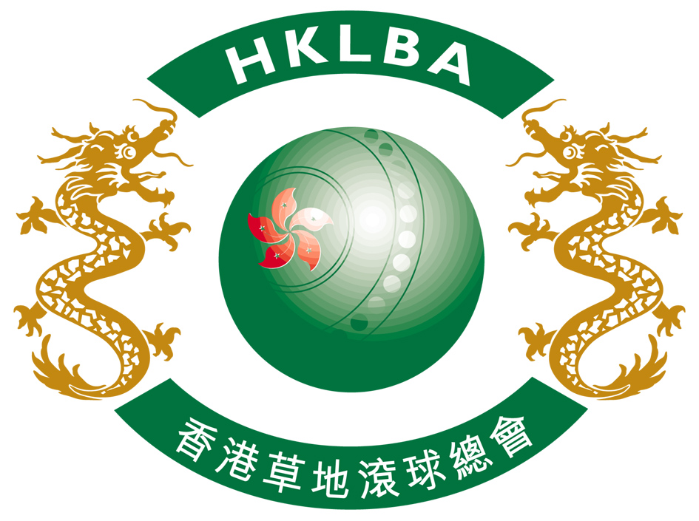
Hong Kong Lawn Bowls Association

2015 Umpire Training Course

The Hong Kong Lawn Bowls Association will once again organise the Umpire Training Course for those who are interested in becoming a lawn bowls umpire.

The course will focus on the two principal competencies required of an umpire. These include the competence in dealing with questions pertaining to the Laws of the Sport of Bowls, and in dealing with the more practical situations which may arise on the green, such as conducting a measure to determine the result of an end.

Starting in April, the course will consist of FOUR compulsory tutorial sessions, each being of 2 hours duration. To ensure the applicants will have a sound physical ability to handle the umpiring duties, a measuring exercise will be conducted in the first session and only those who demonstrate such capability will be admitted for the course. No charge will be imposed on those who fail the evaluation.

During the course, the above competency areas will be covered in the form of discussion on the Laws of the Sport of Bowls, as well as demonstrations and practice on the practical techniques which should be adopted. Homework will be issued at every session to ensure attendants have a thorough understanding of the areas discussed during the tutorial. Participants are not allowed to miss any sessions and fail to hand in homework may seriously affect an attendant’s chance of qualification.

Upon completion of the four tutorial sessions, an examination will be conducted to evaluate the overall standard of the attendants. The result will be used as a guideline for the certification of the umpires.

Entries to the course are opened to those who have at least 3 years of competitive experience in lawn bowls, which will be based on their participation in the HKLBA Premier League and open competitions.

Please note that strong commitment is required from participants and you may need to consider your workload before enrolling for the course.

The sessions will be organised in Cantonese but the home works and written examination will be conducted in English.

For those who have failed in the last two year’s (i.e. 2013 & 2014) umpire written exam can attend this year’s exam if they wish. Please enter your name in the entry form and pay for the exam. fee of HK$100 on the date of exam.

Course Schedule :
Venue 1/F, Meeting Room, Olympic House, 1 Stadium Path,
So Kon Po, Causeway Bay, HK
Time All sessions start at 7:00 pm
Enrolment Fee HK$300 (paid by cheque on the spot)
Session 1 16 April 2015 (Thur.)
Session 2 23 April 2015 (Thur.)
Session 3 30 April 2015 (Thur.)
Session 4 7 May 2015 (Thur.)
Final Examination 21 May 2015 (Thur.))
Re-examination 18 June 2015 (Thur.)
Practical Examination 9 July 2015 (Thur.) at CCC

Course Material All course material will be in English

Closing date 2 March 2015 HKLBA
12 January 2015

